Please run the following 4 commands , as shown in the snapshots below:-

Command1

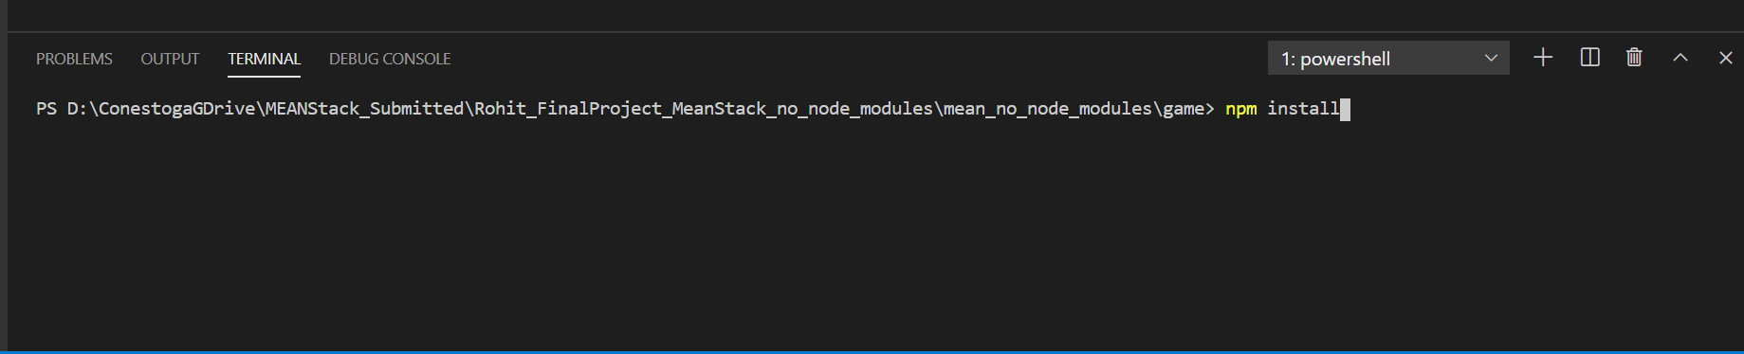

Command2



Command3



Command4

